|  |  |
| --- | --- |
| Name: | Bodhisatya Ghosh |
| UID: | 2021700026 |
| Class: | CSE DS |
| Batch: | B |
| Experiment: | 3 |

**Aim :** The aim of this experiment is to study magnitude spectrum of the DT signal.

**Objective :**

1. Develop a function to perform DFT of N point signal
2. Calculate DFT of a DT signal and Plot Spectrum of Signal. 3.
3. Calculate the effect of zero padding on magnitude spectrum

**Theory:**

* Definition: The discrete Fourier transform transforms a sequence of N complex numbers x0,x1,x2…xn-1 into another sequence of complex numbers, X0,X1,X2…XN-1, which is defined by

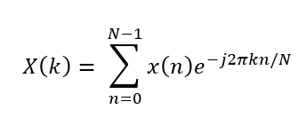

* Properties: Obeys linearity, periodicity, symmetry, parseval’s theorem, shift property.
* Applications: Signal Processing, Audio Processing, Image Processing, Communication Systems, Spectral Analysis, Instrumentation, Data Compression, Fast Fourier Transform.

**Problem definition**:

* Take any four-point sequence x[n]. Find DFT X[k]. Plot Magnitude Spectrum.
* Append the input signal by four zeros. Find DFT and plot Magnitude Spectrum. Give your conclusion.
* Expand the input signal by inserting alternate zero. Find DFT and plot Magnitude Spectrum. Give your conclusion.

**Input specifications:**

* Length of first Signal N
* DT Signal values

**Code:**

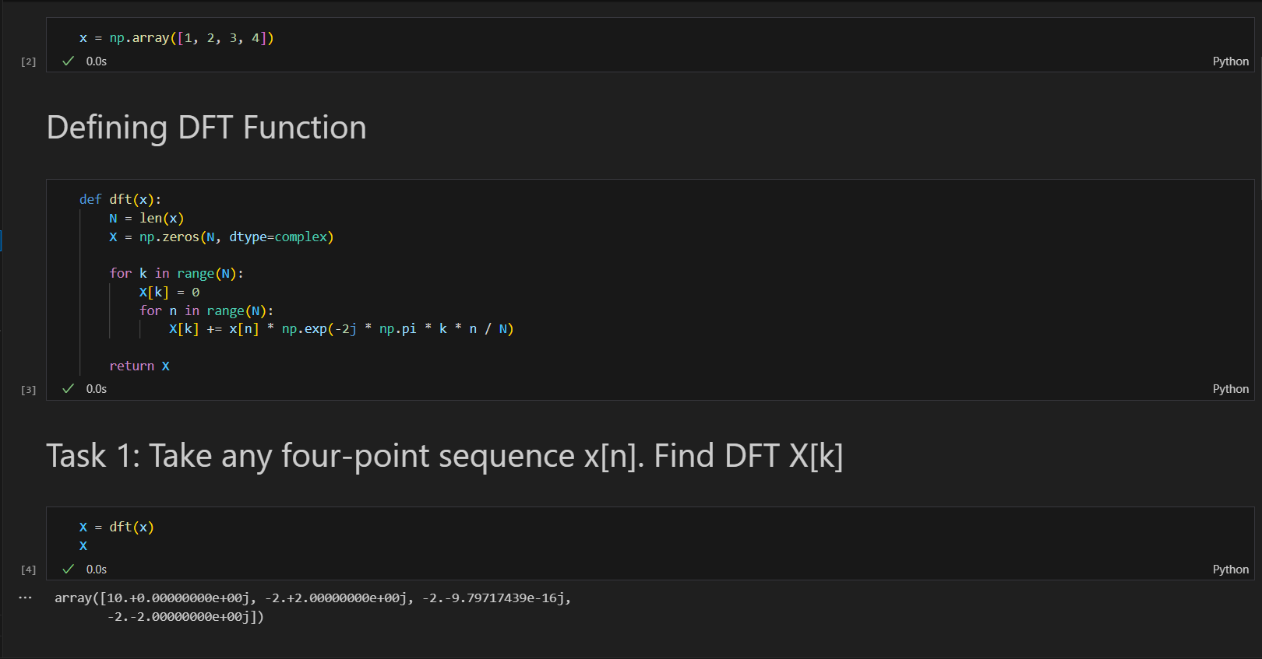

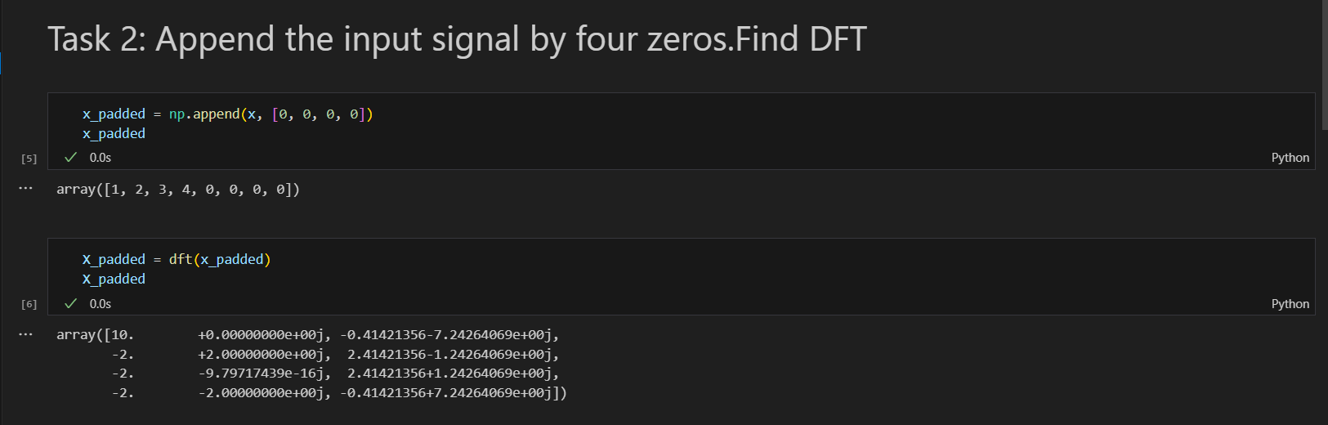

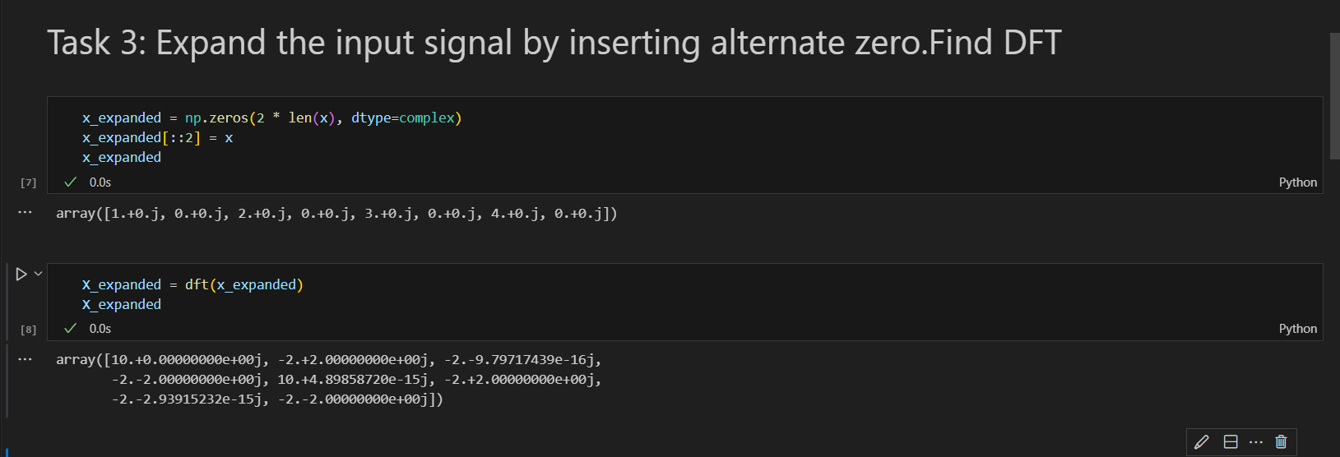

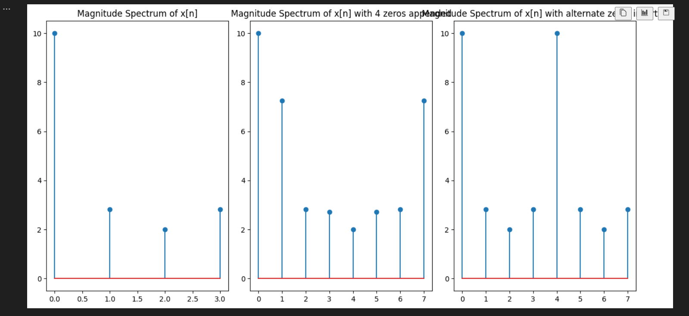

**Conclusion:**

1. The magnitude spectrum of the original 4-point sequence x[n] is plotted.
2. Appending 4 zeros to the input signal leads to a wider DFT spectrum with additional zero frequency components.
3. Expanding the input signal by inserting alternate zeros results in a wider DFT spectrum, with some zero frequency components.